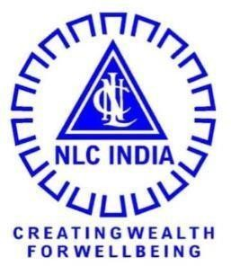

**NLC INDIA LIMITED**

### "NAVRATNA - A GOVERNMENT OF INDIA ENTERPRISE"

**INTERNSHIP REPORT ON**

DATABASE

**SUBMITTED BY**

|  |  |
| --- | --- |
| **R.RANJITH KUMAR** | **(623023104044)** |
| **J.CHANDIRABOSE** | **(623023104009)** |
| **M.VISHNU HARI CHANDRAN** | **(623023104059)** |

## 

**BE., COMPUTER SCIENCE AND ENGINEERING**



**TAGORE INSTITUTE OF ENGINEERING AND TECHNOLOGY,**

**SALEM**

## UNDER THE GUIDANCE OF

**Mr. P.RAJAN**

**CHIEF MANAGER/COMPUTER DIVISION**

**TPS-I EXPANSION/ NLC INDIA**

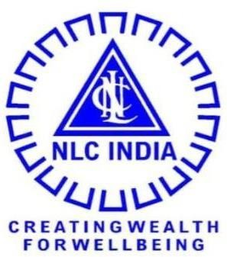

# NLC INDIA LIMITED

("NAVRATNA - A GOVERNMENT OF INDIA ENTERPRISE")

NEYVELI- 607 801, TAMIL NADU

BONAFIDE CERTIFICATE

Certified that the Internship Training report titled "**DATABASE**" is the Bonafide work of

|  |  |
| --- | --- |
| **R.RANJITH KUMAR** | **(623023104044)** |
| **J.CHANDIRABOSE** | **(623023104009)** |
| **M.VISHNU HARI CHANDRAN** | **(623023104059)** |

Studying **BE.,COMPUTER SCIENCE AND ENGINEERING ,TAGORE INSTITUTE OF ENGINEERING AND TECHNOLOGY, SALEM**, done during the period from **20-02-2025** to **01-03-2025** at **THERMAL POWER STATION-1 EXPANSION, NEYVELI.**

Their / His / Her performance, conduct and attendance during the period was (guide has to fill in writing).

SIGNATURE OF THE GUIDE

**MR.P.RAJAN**

CHIEF MANAGER/COMPUTER DIVISION TPS-1 EXPANSION

NLC INDIA LIMITED

Permitted to submit the internship report to college / university authorities.

DATE:

PLACE:NEYVELI

DEPUTY GENERAL MANAGER

LEARNING AND DEVELOPMENT CENTRE

NLC INDIA LIMITED,NEYVELI

DECLARATION

I hereby declare that the Internship training report titled “DATABASE ” is the original work done by us under the guidance of MR. RAJAN, CHIEF MANAGER / COMPUTER DIVISION, TPS-I EXPANSION, NLC India Limited, Neyveli.

This internship report is for reference only and no part of the report will be published copied anywhere without the written permission from officials of NLCIL, Neyveli.

PLACE:NEYVELI SIGNATURE OF THE STUDENT DATE:

**R.RANJITH KUMAR**

**(623023104044)**

**J.CHANDIRABOSE**

**(623023104009)**

**M.VISHNU HARI CHANDRAN**

**(623023104059)**

# 

# ACKNOWLEDGEMENT

Iexpress our sincere thanks to NLC INDIA LIMITED for providing us the opportunity to carry out the Internship Training.

I also express our sincere thanks to **Shri. SARAVANABHAVAN A. Kr, GM / UNIT HEAD L&DC** and the Executives & staffs of Learning & Development Centre for providing us the opportunity to carry out the Internship Training in NLC India Limited, Neyveli.

I sincerely thank **MR.P.RAJAN, CM/TPS-1 EXPANSION/NLCIL**, for providing the guidance during the internship training programme from 21-01-2025 to 17-02-2025.

I express our gratitude to the Unit Head, **Mr.C.KAUSHEEIKA SUBRAMANIAM, General Manager, TPS-1 EXPNASION** for granting us permission to undergo internship training in the Unit.

I sincerely thank **Dr.V.JAY GANESH.ME..,Ph.D.,MBA ,** Principal / **TAGORE INSTITUTE OF ENGINEERING AND TECHNOLOGY** for providing us support and guidance for the Internship.

I sincerely thanks **S.KOKILA,ME** / HOD / CSE DEPARTMENT /

**TAGORE INSTITUTE OF ENGINEERING AND TECHNOLOGY** for encouraging

us to successfully complete the internship training.